GeoGebra Lesson: Using Circles to Construct a Right Triangle
Grades 8-10
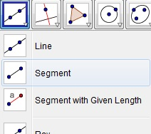
1) Construct line segment AB. (Third tool box)

2) Construct ‘circle with center through point’ two times. (Sixth tool box)
- A as the center & B as the point on circle.
- B as the center & A as the point on the circle.
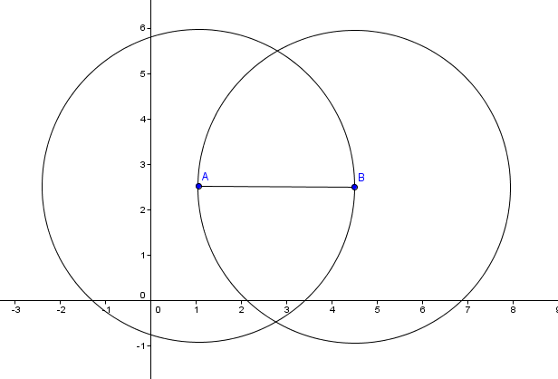

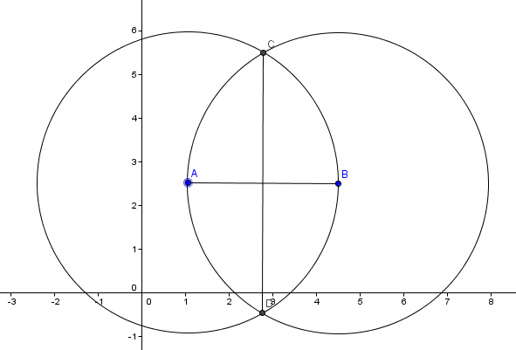
3) Plot the points C and D for the two intersections of the circles. Then connect a line segment CD.

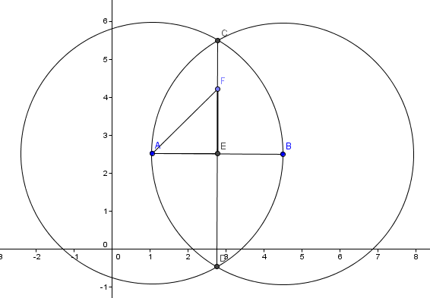
4) Construct perpendicular bisector point E of line segments AB and CD. Then label point F on line CE. Construct line segments AF, FE, AE, and CE.

5) Right click on each line segment AF, FE, and AE and rename them as the following.
AF = m FE = h AE = k
Once labeled… Hide all objects but the four points A, E, F, and C, and line segments AF, FE, AE, and CE. (Note: To hide objects you can right click on object and hit (CTRL+G) or in the Algebra drop down you can click the circles to the left of the label)

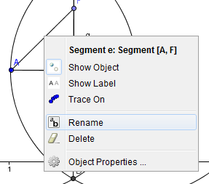

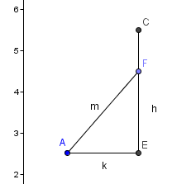

6) Create angle AEF (Eighth tool box) by click the three points F, E, then A.
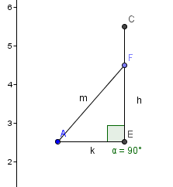

EXTRA for FUN
7) Use text box to create formula for Pythagorean Theorem to prove that no matter where point F moves on line segment CE the triangle we created will remain a right triangle!

